SREYA SUNIL

COMPUTER ENGINEER ENTHUSIAST

# PRO FILE

Motivated student with a strong foundation in Computer Science and a passion for Problem- Solving, seeking an internship or Entry-level position to apply and further develop my skills in Python, Data Structures, Algorithms, and Effective Communication.

# PROJECT/ WORKSHOP

* Borcelle Studio

Marketing Manager & Specialist

2024 - PRESENT

* + Develop and execute comprehensive marketing strategies and campaigns that align with the company's goals and objectives.
  + Lead, mentor, and manage a high-performing marketing team, fostering a collaborative and results-driven work environment.
  + Monitor brand consistency across marketing channels and materials.
* Fauget Studio

Marketing Manager & Specialist

2023

* + Create and manage the marketing budget, ensuring efficient allocation of resources and optimizing ROI.
  + Oversee market research to identify emerging trends, customer needs, and competitor strategies.
  + Monitor brand consistency across marketing channels and materials.
* Studio Shodwe

Marketing Manager & Specialist

2024 - 2025

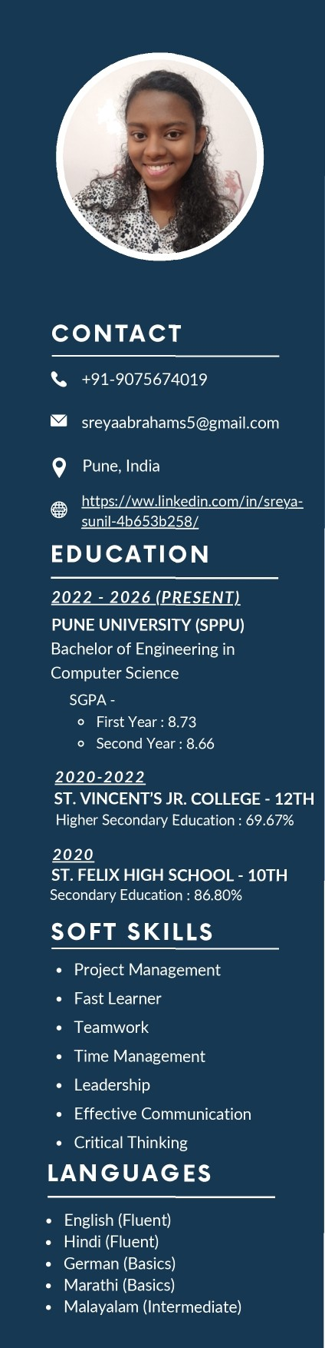

# TEC HNICAL S KILLS

* Programming Languages: Python, HTML, CSS, Bootstrap, JavaScript, C++, Java (Basics)
* Course Work: Database Management System, Data Structure & Algorithms, Software Engineering, Microprocessor, Computer Networking & Systems, Software Project Management
* Operating System: WINDOWS, UBUNTU, LINUX
* Tools: EXCEL, PPT, WORD, POWER BI
* Certificates: CPP, ADVANCED CPP organized by SITS, NARHE